PERSONAL INFORMATION | Briukhovetska Iryna
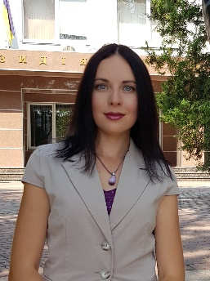 |   Kyiv, Ukraine
 |  +380980808045


IBriukhovetska@maup.edu.ua
 | ORSID: https://orcid.org/0000-0002-1469-1485
 | Google scholar: https://scholar.google.com/citations?hl=ru&amp;user=NZvqAb0AAAAJ
 | Date of birth 27/04/1989 | Nationality Ukrainian

WORK EXPERIENCE

[Add separate entries for each experience. Start from the most recent.]

Interregional Academy of Personnel Management (IAPM)

Associate Professor of the department of Finance, Banking and Insurance, 2019 - present

Teaching disciplines:
- Financial theory
- Financial services market
- International finance
- Financial management
- International financial and credit organizations

EDUCATION AND TRAINING

[Add separate entries for each course. Start from the most recent.]
2018 | To defend a candidate dissertation “ Insurance of property of citizens and directions of activation of its development.. Ph.D.
2011/2017 | Kyiv National Economic University named after Vadym Hetman, Postgraduate studies
2006 - 2011 | Kyiv National Economic University named after Vadym Hetman, Master's degree in finance

Mother tongue(s) | Ukrainian
Other language(s) | UNDERSTANDING |  | SPEAKING |  | WRITING
 | Listening | Reading | Spoken interaction | Spoken production
English | В2 | В2 | В2 | В2 | В2

Communication skills | good communication skills

Organisational / managerial skills | leadership

ADDITIONAL INFORMATION

Publications  Presentations  Projects  Conferences  Seminars  Honours and awards  Memberships  References  Citations  Courses  Certifications | The author of research more 80 articles in economic area (banking, finance, digital)  Major publications (specify 5 publications):  1. Briukhovetska, I. (2022). State policy on regulation of banking activities in case of corporate client bankruptcy. Scientific Works of Interregional Academy of Personnel Management. Political Science and Public Administration., (1 (60), 5-9. https://doi.org/10.32689/2523-4625-2021-1(60)-1  2. Briukhovetska, I. (2022). Economic policy in the context of innovative transformations in Ukraine. Scientific Works of Interregional Academy of Personnel Management. Political Science and Public Administration., (1 (59), 5-9. https://doi.org/10.32689/2523-4625-2020-1(59)-1  3. Briukhovetska I.O. Selection of an innovation object by an insurer for financing / Briukhovetska I.O., Yatsenko V.V..// The 44th International scientific and practical conference «Recent Trend in Science and Technology», Berlin,December 29-30, 2022. Munich, Germany: Littera Verlag, 2022. – P. 29-33. [in Ukrainian].

ANNEXES

- copies of degrees and qualifications;
- testimonial of employment or work placement;
- publications or research.

Will be provided upon additional request

